**Group 12 Project Contribution**

| **Section** | **Contributor** | **Student Number** |
| --- | --- | --- |
|  | Luke Shi | 200608140 |
|  | Luke Shi | 200608140 |
|  | Luke Aikman | 201652750 |
|  | Branden Wheeler | 190197360 |
|  | Luke Aikman | 201652750 |
|  | Amirhossein Kompanizare | 130783830 |
|  | Haniah Khan | 200687050 |
|  | Ninam Rai | 200619540 |
|  | Branden Wheeler | 190197360 |
|  | Naimo Yasin | 201640360 |

# Introduction

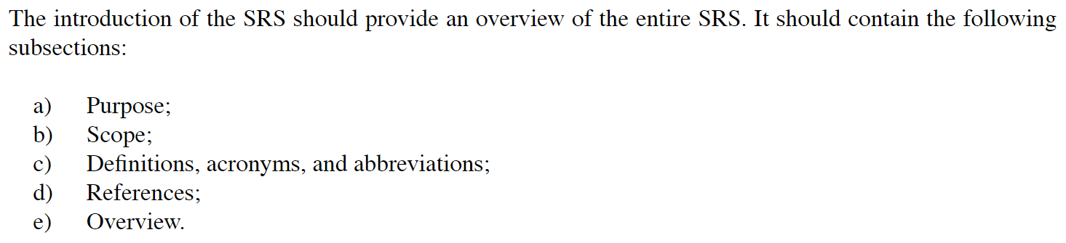

## 1.1 Purpose

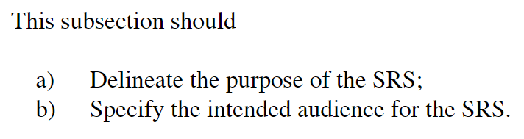

## 1.2 Scope

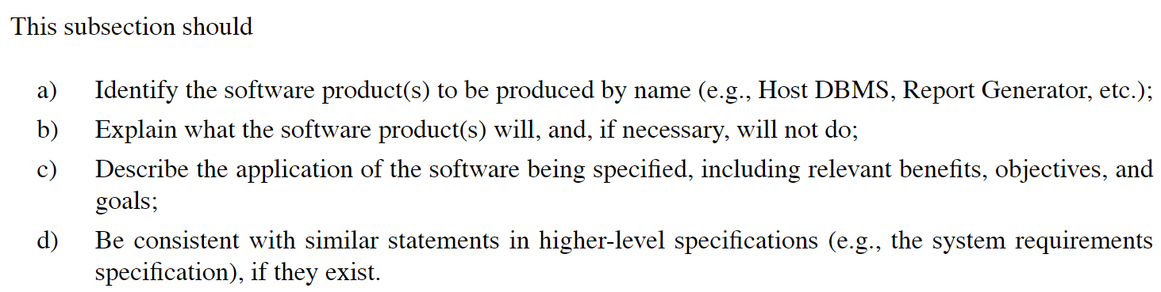

## 1.3 Definitions, Acronyms, and Abbreviations

NFC

SRS

API

POS

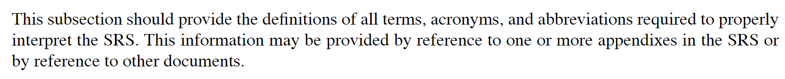

## 1.4 References

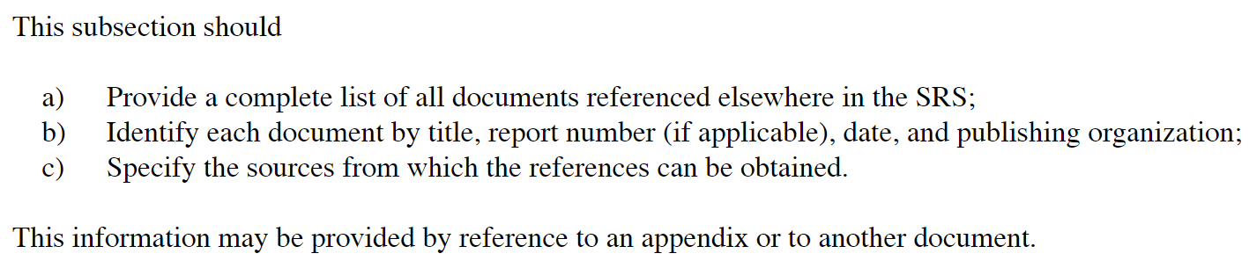

## 1.5 Overview

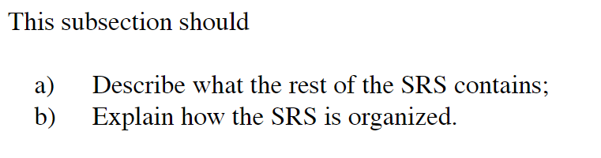

# Overall Description

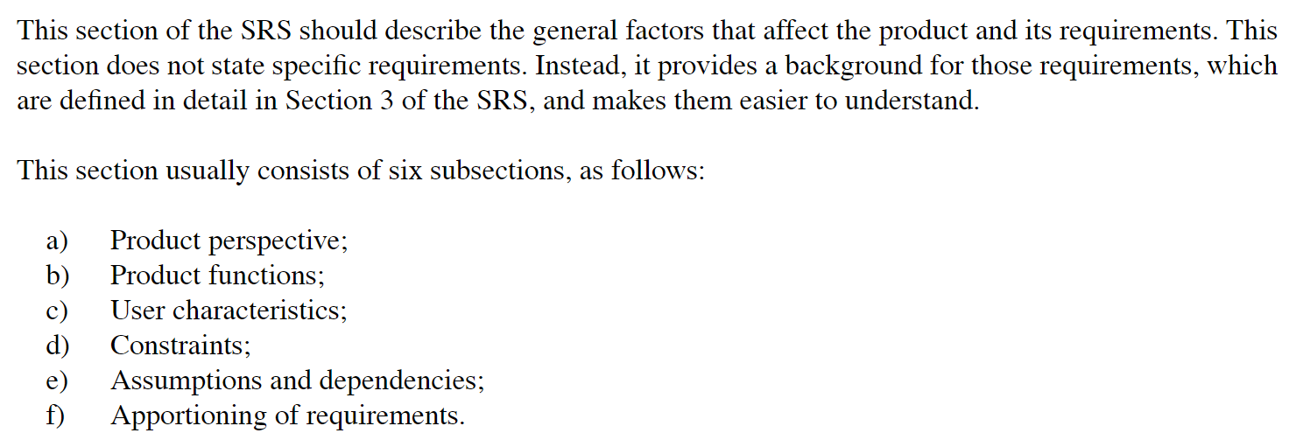

## 

## 

## 2.1 Product Perspective

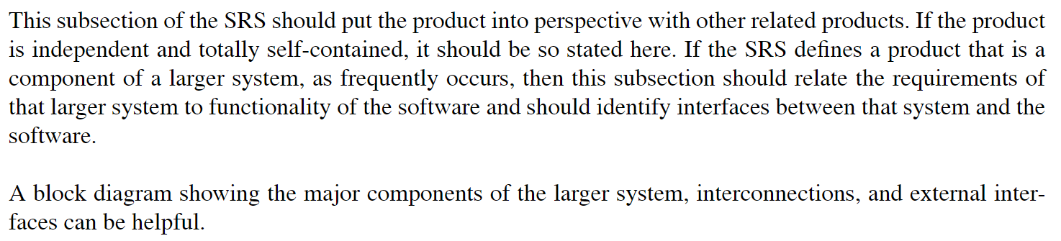

## 

## 2.2 Product Functions

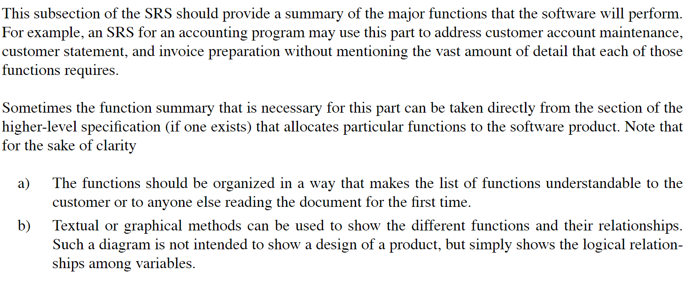

## 2.3 User Characteristics

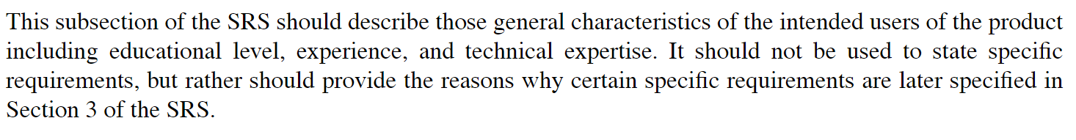

## 2.4 Constraints

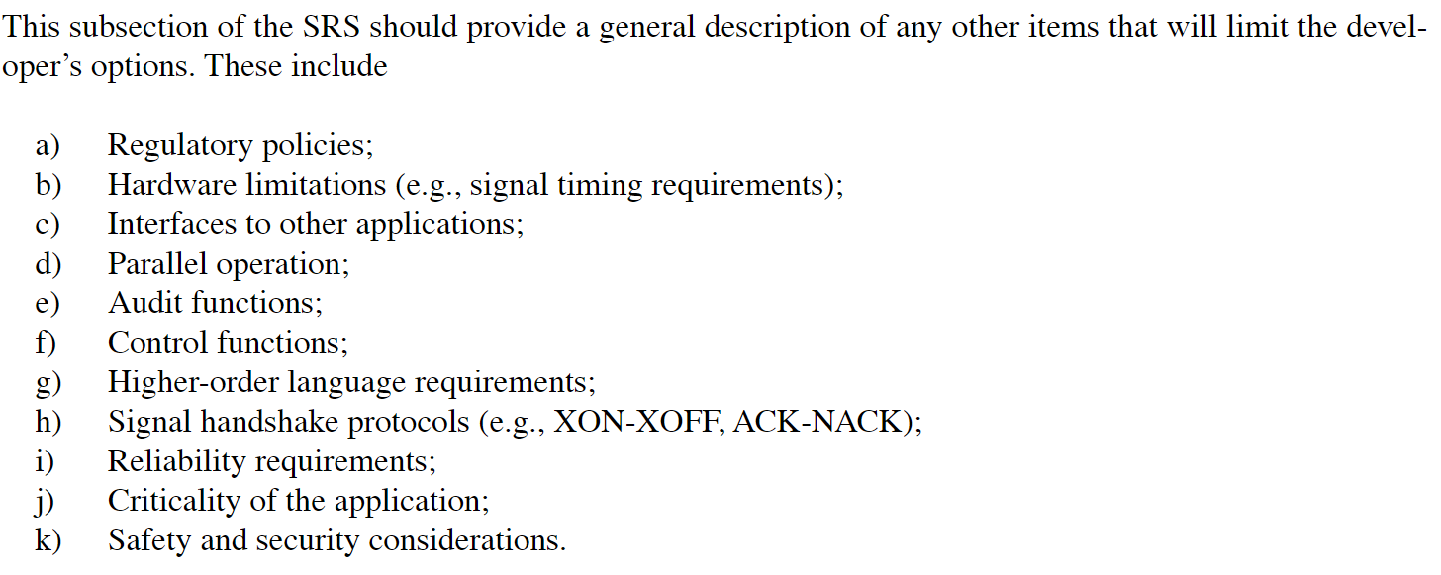

## 2.5 Assumptions and Dependencies

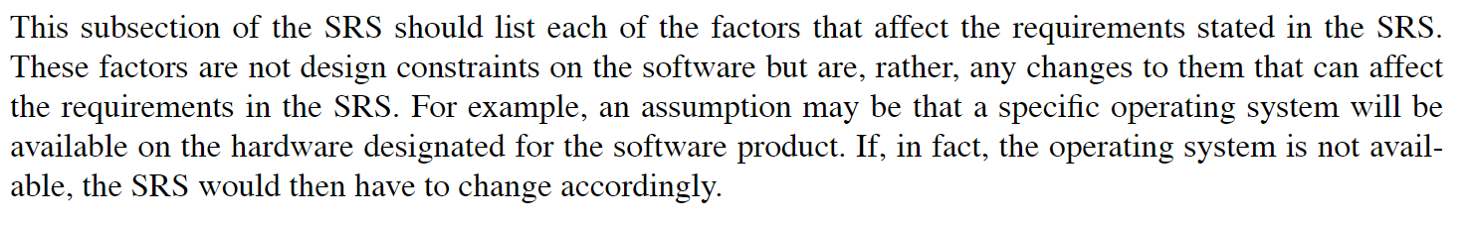

# Specific Requirements

## 3.1 External Interface Requirements

### 3.1.1 User Interfaces

### 3.1.2 Hardware Interfaces

### 3.1.3 Software Interfaces

### 3.1.4 Communications Interfaces

## 3.2 System Features

### 3.2.n System Feature n

#### 3.2.n.1 Introduction/Purpose of Feature

#### 3.2.n.2 Stimulus/Response Sequence

#### 3.2.n.3 Associated Functional Requirements

##### 3.2.n.3.m Functional Requirement m

## 3.3 Performance Requirements

## 3.4 Design Constraints

## 3.5 Software System Attributes

## 3.6 Other Requirements

**Possible System Features**

Receive receipt via tap

View receipts

Aggregate info

Average spending (per month, week, etc)

Categorize spending

Will need to manage categories